how to select a cell without deselecting another in excel 2013

In Excel 2013 and newer versions, it is possible to select cells without losing the selection of other cells. This feature allows for convenient simultaneous cell selection. The benefit of selecting a cell without deselecting another in Excel is that it allows for efficient data manipulation and analysis. By maintaining the selection of multiple cells, you can perform operations on them simultaneously, such as copying, formatting, or applying formulas. This saves time and effort compared to repeatedly selecting and deselecting cells, enabling smoother workflow and enhanced productivity.

Using this dataset, we will explore the process of selecting individual cells while retaining the selection of previously chosen cells. The dataset contains extensive sales data for 26 products, including monthly sales figures across multiple years.

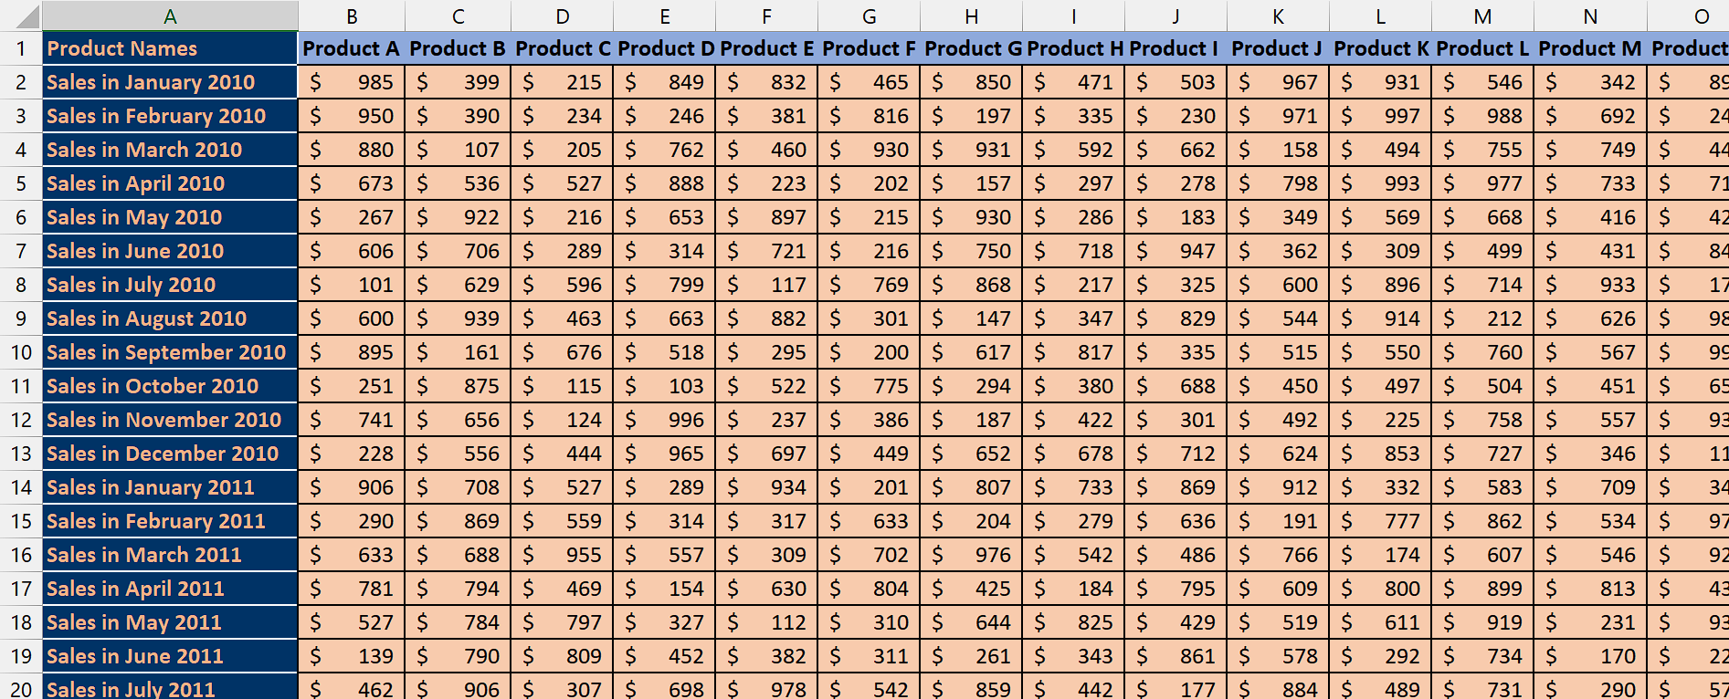

## Step 1 – Select the first cell

* Hover your mouse over the first cell you want to select.
* Then, left-click to select the cell.



## Step 2 – Select multiple cells simultaneously

* After selecting the first cell, press and hold the “Ctrl” button on your keyboard.
* Then, hover your mouse over the second cell that you want to select.
* Click on the second cell while press “Ctrl” button and your two cells will be selected and the first cell will not be deselected.
* This method allows you to select any number of cells you desire.

